**Scramp Dexterous Hand**

Technical specification

# Overview

The Scramp Dexterous Hand is an anthropomorphic robotic hand that provides 22 movements to reproduce as closely as possible the kinematics and dexterity of the human hand. Thanks to the high number of controlled degrees of freedom and similarity of the human hand, it has been designed to provide comparable force output and movement precision to the human hand. It can be used for research in grasping, manipulation, neural control, brain computer interface, industrial quality control, and hazardous material handling.

The Scramp Dexterous Hand provides all necessary basic parts for the professional application development and includes:

* Control System
* Software
* PC
* Power supplies
* Video and Documentation for training program

The communication can be finished based on both RS485 or USB. The normal version robotic system provides the available RS485toUSB fieldbus, which is easily integrated with our robot control device.

The design is modular that allows any variation of the original version on request, including changes in dimension, number of fingers or right-left hands.

This document describes the the foundation knowledge of Scramp Dexterous hand and the necessary steps to run this hand and modify the movements.

# Mechanical part

## Dimensions

The Scramp Hand can be divided in three main sub-assemblies. Both left and right hand version have the same shape and size:

* The hand composed of five fingers and the palm;
* The wrist composed of the link with palm, an intermediate articulation and the link with the forearm;
* The forearm in which all the servomotors are located

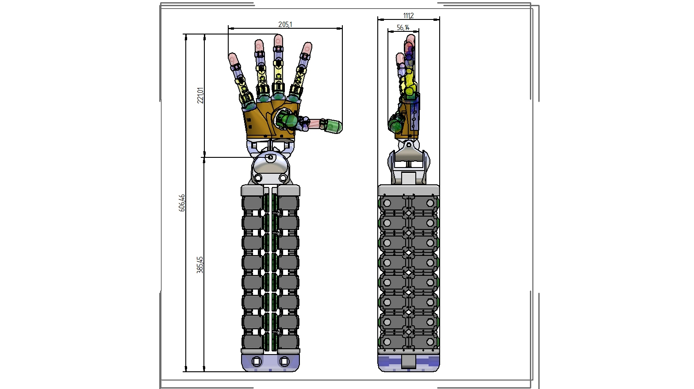

The fingeris composed of five links, which are named as Distal phalange, Middle phalange, Proximal phalange, Proximal-Metacarpal articulation and Metacarpal bone from upper side to downside. The dimensions are illustrated as below:

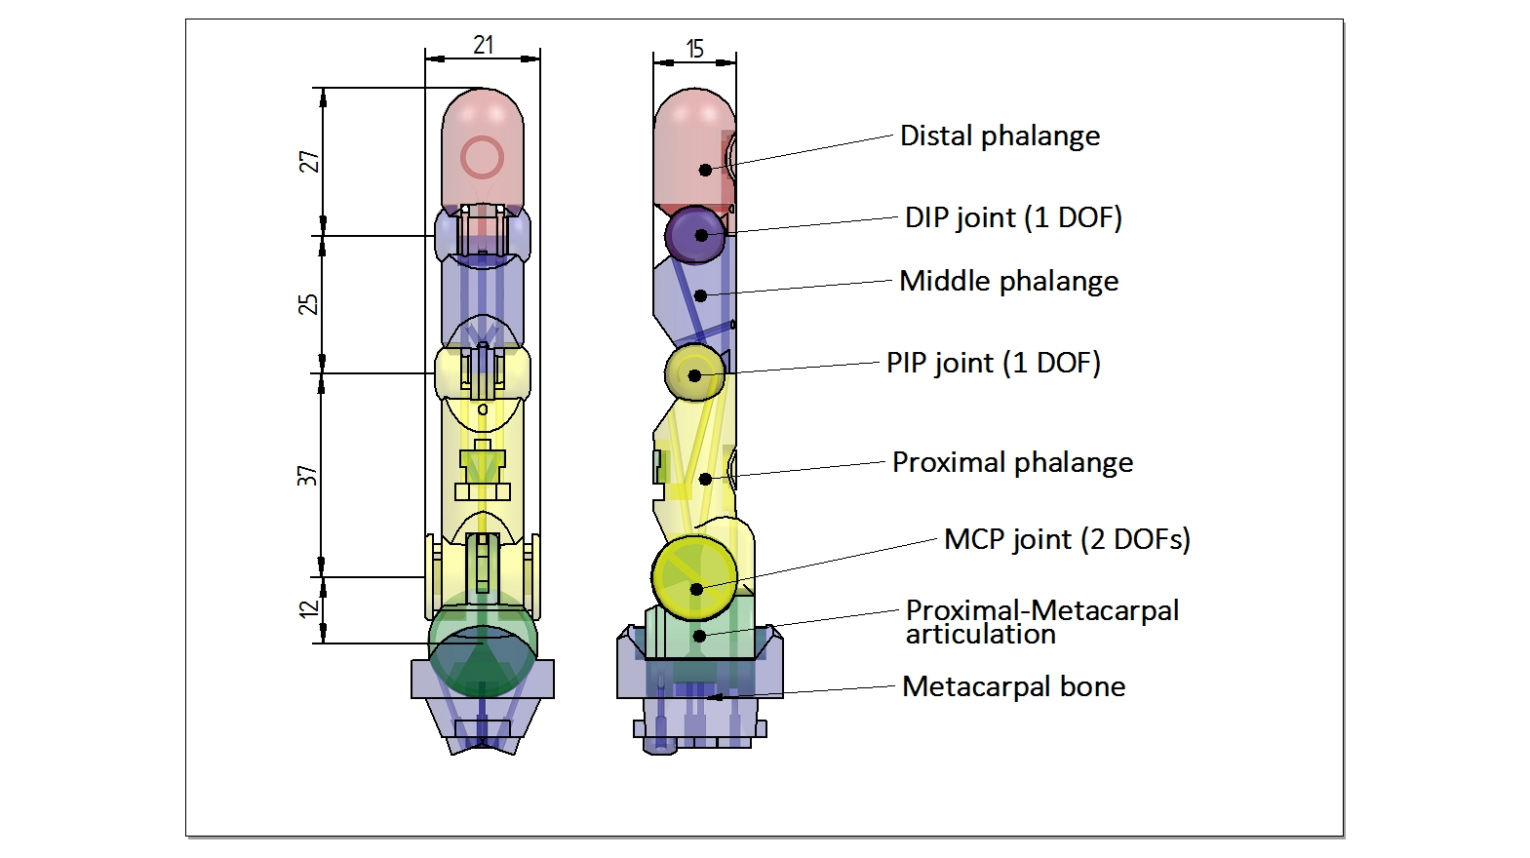

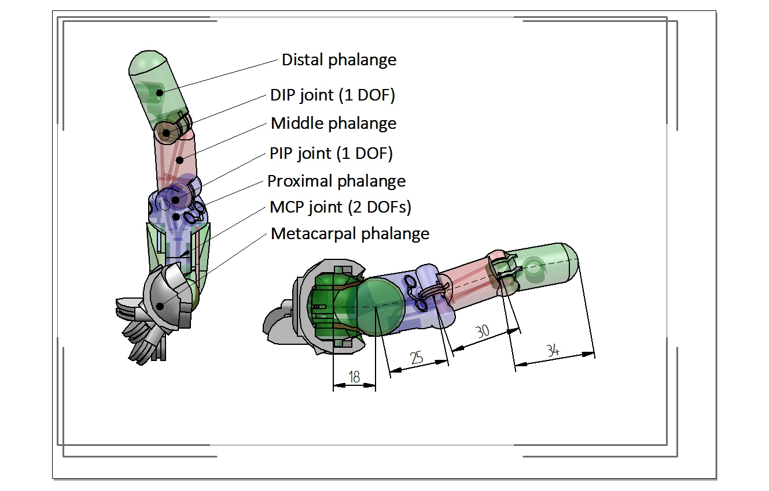

|  |  |  |  |  |  |
| --- | --- | --- | --- | --- | --- |
|  | Thumb | Index | Middel | Ring | Little |
| Prox_MCArticulation | 18 | 12 | 12 | 12 | 12 |
| Proximal Phalange | 25 | 37 | 44 | 39 | 34 |
| MiddlePhalange | 30 | 25 | 25 | 25 | 25 |
| Distal Phalange | 34 | 27 | 27 | 27 | 27 |

The hand and forearm have a total weight of 4.5 Kg. Movement speed can be set by the control. The maximum speed achievable for the complete closure oft he fingers is about 0.3s.

## Kinematic structure

The Scramp Dexterous Hand kinematics are optimized to be as close as possible tot he kinematics of the human hand. Each finger movement are determined by it’s three joint, which are easily signed by index number with finger name. Index 0 means the MCP joint movement towards left or right, when Index 1 indicates the MCP joint movement towards up und down. Index 2 means the PIP joint movement towards up und down, which the DIP joint movement is coupled with.

|  |  |  |  |
| --- | --- | --- | --- |
| Joints | Degrees | | Notes |
| Min | Max |
| Thumb 0 | 0 | 70 |  |
| Thumb 1 | 0 | 85 |  |
| Thumb 2 | 0 | 75 |  |
| Index 0 | 0 | 20 |  |
| Index 1 | 0 | 70 |  |
| Index 2 | 0 | 80 |  |
| Middel 0 | 0 | 20 |  |
| Middel 1 | 0 | 70 |  |
| Middel 2 | 0 | 80 |  |
| Ring 0 | 0 | 20 |  |
| Ring 1 | 0 | 70 |  |
| Ring 2 | 0 | 80 |  |
| Little 0 | 0 | 20 |  |
| Little 1 | 0 | 65 |  |
| Little 2 | 0 | 80 |  |

## Actuation

The actuation is based on electric servomotors. On the output shaft of the motors is flanged a pulley where an extremity of the tendon is anchored. The tendon is guided through the forearm and the wrist by an elastic conduit. The other extremity of the tendon is anchored directly on the phalange.

The servomotors are produced by Robotics INC and the model adopted is Dynamixel RX-28.

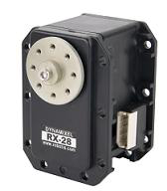

|  |  |
| --- | --- |
| WEIGHT | 72g |
| DIMENSION | 35.6mm x 50.6mm x 35.5mm |
| RESOLUTION | 0.29° |
| GEAR REDUCTION RATIO | 193 : 1 |
| STALL TORQUE | 3.7N.m (at 18.5V, 1.9A) |
| NO LOAD SPEED | 85rpm (at 18.5V) |
| RUNNING DEGREE | 0° ~ 360° orEndless Turn |
| RUNNING TEMPERATURE | -5℃ ~ +80℃ |
| VOLTAGE | 12V~18.5V (Recommended Voltage 14.8V) |
| COMMAND SIGNAL | Digital Packet |
| PROTOCOL TYPE | RS485 Asynchronous Serial Communication (8bit,1stop, No Parity) |
| LINK(PHYSICAL) | RS485 MultiDropBus |
| ID | 254 ID (0~253) |
| COMMUNICATION SPEED | 7343bps ~ 1 Mbps |
| FEEDBACK | Position, Temperature, Load, Input Voltage |
| MATERIAL | Full Metal Gear, Engineering Plastic Body |
| STANDBY CURRENT | 50 mA |

The pulleys on the motor side have radius 11.5mm.

# Application

## Control

The control of the hand can run based on our robot control device – robot controller, which has been special designed for robot application. It allows user using simple PLC program to control the hand movement and extend different functionality based on the feedback information. Otherwise, the user can additionally set:

* the speed of execution of the movement;
* the maximum torque of the motors;
* the PID constants of the position motor controller.

The linkage of Dexterous hand with robotic arm can be accomplished by using the same robot control device, which supports the EtherCAT communication with other robotic system. A self-modified device configuration file is required, in which the hand joints can be taken as auxiliary axis of the normal robot axis.

## Open source and training

All source code for the dexterous hand and the necessary detail materials for application development based on this hand are available on request. Example code for hand movement with documentation are provided. Videos or tele-training program are available for our customer for a quick startup.

# Startup with Demo movement

Our robotics hand system package includes:

* One compact Dexterous Hand, which is integrated with a little size power box in the bottom
* One robot controller
* Two USB cable
* Power cable
* Documentation, Codesys Library and Device configuration file
* PC software (Codesys SP8 V3.5 and GUI)

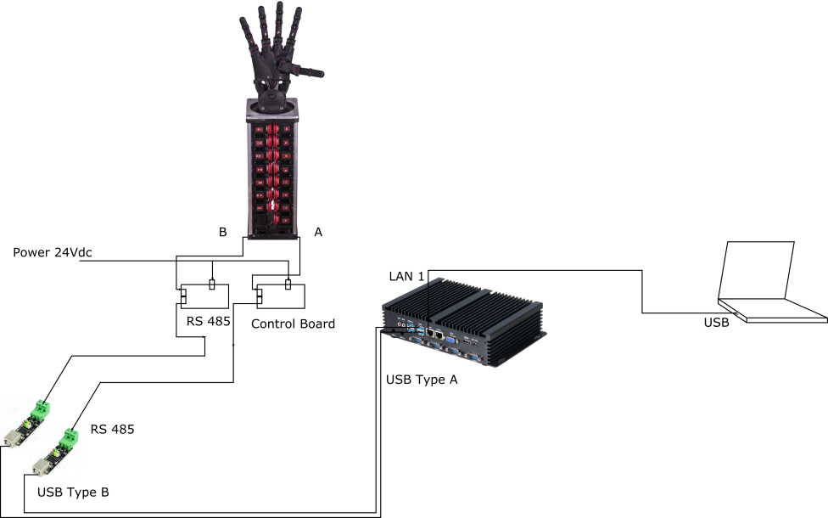

The first step to run this hand is connecting all parts as the picture shown. Power on the little size power box and connect it to the robot controller using USB cable. Note that the output „A“is connect with the Connector besides LAN1 when „B”is in the left side of connector of „A“. Then connect the LAN1 to the PC using the normal WLAN cable.

## Installation of Codesys

Run the Installation Guide of Codesys and finish the basic steps.

After codesys is success installed on the PC, click the demo PLC program and it will generate an alarm that warnsthe missing library. Follow the steps to download the library.

* Select the tool bar „Tools->Device Repository“ and click on „install“, select the file „ARC_Controller.devdesc.xml“ on the PC and add the ARC device in the repository.
* Select the tool bar „Tools->Library Repository“ and click on „install“ and add the file „ArcaLibrary_compiled-library“.
* Once the procedure is done, click on „Close“
* For the missing standard library of codesys, click on the „Library manager“ on the left tool bar, select one missing library
* In the window of „Library Manager“, click on „download missing library“ and wait for installation
* After finished, the underline of the missing libraries disappears.
* If the missing standard library can not be downloaded, close the firewall, try it again. When not yet, contact us under info@scramprobotics.com.

## Installation of GUI

There is no requirement of installation of GUI, it can be directly used on the windows PC. Before using it to control the hand, please modify the local network setting of PC. A fixed IP address with the format „192.168.80.xxx“ for the local WLAN connection is necessary.

## Introduction to GUI

GUI – graphical user interface has been special designed for our robotic system, which supports the manual setting of robot joints and the switch of control mode. By using it to control the robot, the device configuration file must be modified according to the robotic system. Four default configuration files are set in the device.

* Ethercat configuration file: This “xml” file declares the information which are necessary for the Ethercat communication between robot controller and robotic system.
* Motion Configuration file: This file contains the axes and robot system information which defines the physical and mechanical constraints of the robotic system.
* Hand Configuration file: This file is only needed for the Product “Dexterous Hand” and “Smart 3-Finger-Gripper”, which notes the basic information about the auxiliary axes.
* Vision Configuration file: This file is used for the robotic vision system and contains the necessary information of camera.

Detail information about GUI can be found in “Robot Controller User Manual” Chapter 2.

## GUI control for single joint movement

* Open GUI and wait for connection
* Click on the button „Configurationfile“ and uploads the device configuration file one by one, then reboot the device
* Change the user level as „GUI/CNC control”
* Click on the axis „Thumb 0“ and „Switch ON“
* Slow down the JOG speed and Jog the single axis in both directions
* (It is also possible to set the actual position as zero position or what user needs by click on „Homing“)
* „Switch off“ the joint
* Repeat the steps for other joints

## PLC control for demo hand movement

* Change the user level of GUI to „PLC control“
* Open demo PLC program
* Click on „Device“ and „Scan device“ for connection
* Open „main“ file
* Click on „Online“ and „Log in“ in the action bar
* Click the prepared value for „enable“ on the main Window and set it to true. See the GUI, all axes should be switched on.
* Click the prepared value for „demo start“ and „start move“ on the main Window and set it to true. Hand starts moving.
* Change the value of „ovl“ for different speed
* Change the value of „torque“ for different torque

More detail information about Codesys installation and GUI user Guide see „Robot controller user Guide“- chapter 1 and chapter 2.

## Most asked Question

**After powered on the single axis in the GUI, the motor does not move.**

In that case, the motor that is powered on shows red in the GUI and it means failure to switch on. The reason may be the connection of USB cable are in opposite position. Check the cable, reboot the device and try it again.

**In PLC mode, set the command value as „ TRUE“ but hand don’t move.**

Check the GUI, if all axis are powered on. When error, switch off the device and check the cable and Jog the single axis by using GUI. After succeed, switch to „PLC control mode“ and try it again.

**Which code or commands can be used for movement programming?**

In the demo program, lots of syntax and commands are used for demo show. In the Library manager, click on any one installed library, user can find different useful commands.